Philippine Normal University

Code of Research Ethics and
Guidelines for Review

¹Approved by the Board of Regents on June 11, 2015
²Recommended for BOR approval by the PNU Administrative Council in its meeting on May 5, 2015
³For dissemination and orientation - First Term of AY 2015-2016
⁴For trial implementation for two (2) terms, beginning the Second Term of AY 2015-2016. Revisions and Amendments when necessary shall be done within these first two (2) terms (Second, Third Terms, AY 2015-2016).
⁵Implementation of the revised code and guidelines will be done in June 2016.

Contents

Code of Research Ethics
A. Preamble
B. General Ethical Principles
C. Framework
D. Basic Ethical Standards in Research
The PNU Research Ethics Committee
A. Functions
B. Composition and Terms of Reference
C. Schedule of Meetings
Research Ethics Review Guidelines
A. General Flow of the Review Process
B. Guidelines for Submitting Research Proposals
and Reports for Review of the REC

CODE OF RESEARCH ETHICS
A. Preamble
The Philippine Normal University, the National Center for Teacher Education, with its core values of truth, excellence and service, adheres to the principles of respect, beneficence and justice, in pursuit of research practice for the advancement of education science.
B. General Guiding Principles in Ethical Education Research
The Philippine Normal University maintains ethical research practice to promote scholarship of research.
Respect:
Research endeavors uphold respect for life, dignity and reputation of both researchers and participants/subjects, with special and appropriate protection for vulnerable groups.
Beneficence:
The best interest of the research participants/subjects is paramount.
Justice:
Research intentions and processes adhere to generally accepted scientific principles.
C. Framework

The outer circle of the framework (Figure 1) depicts the core values of excellence, truth and service as the foundation in the conduct of research in the university. Excellence shall be the primary goal of all PNU scholars. The PNU community shall strive to ensure and maintain high standards and quality in the conduct, data safekeeping and reporting of any research work. Truth refers to the promotion of honesty and fairness in the way human beings are treated or involved in the data gathering and dissemination of results. Service promotes accountability for the data collected and reported. In the inner part of the circle of figure 1 shows the three internationally and nationally recognized guiding principles in the conduct of research involving human subjects: Respect, Beneficence and Justice. Each of the general principles in this code has been translated into several ethical standards fitted in the conduct of research in a teacher education institution. These standards shall serve as the criteria for the research ethics review process in the university.
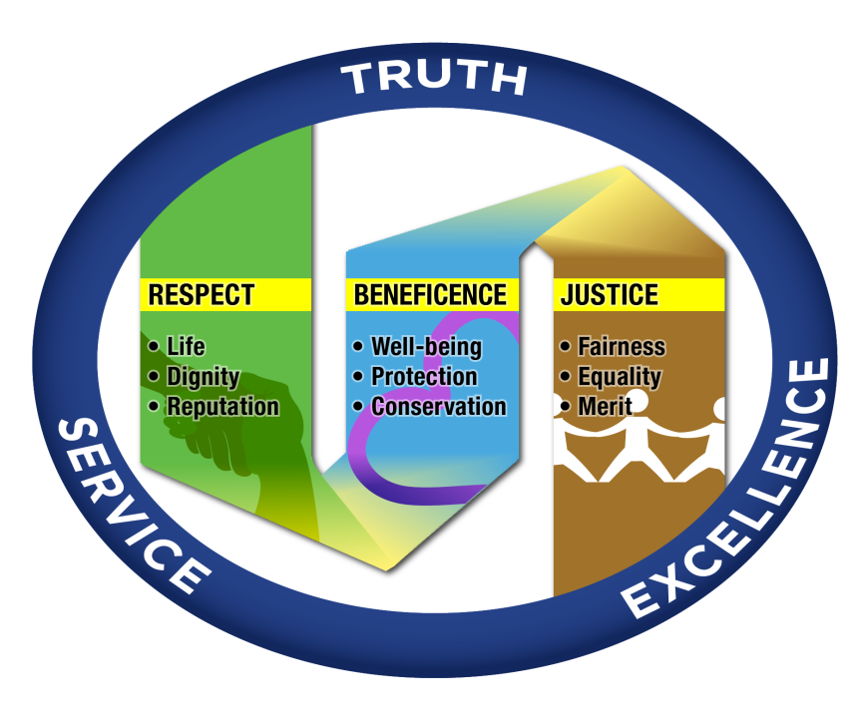
Figure 1: The PNU Code of Ethics Framework

D. Basic Ethical Standards in Research
Guided by the principles of respect, beneficence and justice, the basic standards for the ethical conduct of research in all its various aspects are described in this section.
General Principles | Basic Ethical Standards
Respect | - Research endeavors ensure the physical and psychological safety, and protection of researchers and participants/subjects.  - Participation in research is voluntary with informed consent.  - All information from the participants is handled with utmost confidentially and with agreement to grant anonymity.
Beneficence | - Optimize benefits and minimize possible harm in the conduct of research.  - Direct and indirect benefits resulting from the research are shared to the participants and communities.  - Research contributes to improve human condition.

Justice | - Inclusion and exclusion criteria in the selection of research participants/subjects, data collection tools, and methodology are free from any biases (e.g., gender, class, ethnic, cultural biases).  - Conflict of interest principle applies in all research activities.  - Research is conducted by individuals with appropriate ethics, scientific education, training and qualification.

The PNU Research Ethics Committee

- Functions
The PNU Research Ethics Committee (PNU-REC) ensures conduct of research in accordance with the university’s Research Code of Ethics. Specifically, the REC reviews, approves or recommends improvements to research proposals to meet ethics requirements. The REC issues clearance to proceed before the conduct of research and certificate of compliance upon completion of the study.

- Composition and Terms of Reference
The PNU Research Ethics Committee is an independent and multidisciplinary committee attached to the Office of the VPRPQA. The committee is composed of five (5) regular members and additional experts in the discipline may be invited as needed.

Designation | Composition | Responsibilities
Chair | Full Professor recommended by the VP for Research, Planning and Quality Assurance | - Reports directly to the PNU Vice President for Research, Planning and Quality  - Convenes the REC to review, approve or recommend improvements to research proposals to meet ethics requirements.  - Determines and recommends composition of REC experts’ pool for the review of specific research proposals / completed research projects.  - Serves as the chair for a research panel.
Co-Chair | Full Professor recommended by the VP for Research, Planning and Quality Assurance | - Assists the REC Chair in all tasks related to the REC functions; and  - Serves as the chair for a research panel
Regular Members | Research Directors or their authorized representative  - EPRDC  - RCTQ  - GRESO | - Review research proposals/completed research projects to ensure alignment to the University Research Code of Ethics
Experts from the discipline as needed | Faculty members from the Colleges/Faculties as designated by the OVPRPQA | - Attends REC meetings by invitation  - Reviews proposals / completed research projects in accordance with ethical guidelines and standards acceptable in their specific fields or disciplines.

The REC is assisted by a Secretariat composed of a Faculty-in-charge of the EPRDC Desk on Research Ethics and two (2) support staff (from the EPRDC and CGSTER) who takes care of the receiving applications and releasing of review results, documentation and archiving.

The Committee is divided into two research panels which simultaneously perform the review processes (proposals/completed research output). The composition of the review panels:

Research Panel 1 | Research Panel 2
REC Chair  2 Members (1Research Director and 1 expert) | REC Vice Chair  2 Members (1Research Director and 1 expert)

- Schedule of Meetings
The two research panels of the Research Ethics Committee are expected to deliberate on submitted research proposals or research report every second Wednesday of the month. A full board meeting of the committee shall only be held when the need arises (e.g. proposals/ completed reports which were found to have a high level of potential harm on the research participants as recommended by any of the research panels or there is a need to deliberate on issues and procedures arising on the review processes and ethical standards).
Research Ethics Review Guidelines

- General Flow of the Review Process

- All research proposals and completed research projects / theses/ dissertations follow the flowchart in Figure 2.
- Graduate student research proposals and completed theses and dissertation are submitted to the GResO for endorsement to REC. For PNU Hubs (North Luzon, South Luzon, Visayas and Mindanao, the equivalent office of the Graduated Research Office (GResO) of the Main Campus shall be in-charge of endorsing their respective graduate students’ theses and dissertations to the REC.
- RCTQ-initiated research protocols and completed research output are reviewed and endorsed by RCTQ to REC.
- Faculty/administrative staff research proposals / completed research outputs without funding are submitted to EPRDC for endorsement to REC. Funded research projects (e.g. Project-based Research Grant or Commissioned Research) are endorsed by the EPRDC for review of the RECC and for final approval of the Board of Regents through the Administrative Council. Nevertheless, once approved by the RECC, endorsement to REC will be undertaken by the EPRDC simultaneously.

*Completed report should not pass through the RECC, Administrative Council and BOR
Funded Research Projects
(Proposal and Completed Report)*

EPRDC
Faculty Research Projects
(Proposal and Completed Report)
Figure 2. Research Ethics Review Flowchart
Board of Regents
Administrative Council
Research and Extension Coordinating Committee (RECC)
RCTQ
RCTQ-initiated Research Projects (Proposal and Completed)

Research Ethics Committee (REC)
GResO
Student’s Thesis and Dissertation
(Proposal and Completed)
- Guidelines for Submitting Research Proposals /Reports to REC
- The applicant (researcher/research team) should accomplish the Proposal Review Form with the research proposal, including all the tools for data collection and the consent form/s, in three (3) sets/copies and submit to the REC Secretariat.
- For completed research reports, the applicant (researcher/research team) should accomplish the Research Report Review Form with a copy of the completed research project / research article, in three (3) sets/copies and submit to REC Secretariat.
- All applications should be received by the REC Secretariat at least five (5) working days before the scheduled monthly meeting (every second Wednesday of the month) to ensure inclusion in the agenda.
- Schedule of the meetings shall be available at the PNU website. The schedule of meetings for one academic year shall also be posted in the CGSTER and EPRDC Bulletin Boards.

- Guidelines for the Review of Research Proposals/ Reports by the REC
- The REC Chair through its secretariat is responsible in receiving applications and distributing the copies to the designated research panel for the ethical review.
- The designated review panel carefully reviews the proposals/reports based on the ethical principles set in the PNU code of research ethics.
- The Clearance to Proceed is issued to qualified research proposals before the conduct of research. In case of major changes in the proposal, appropriate recommendations are given for further compliance. For qualified completed research, the Certificate of Compliance will be issued by the REC.
- The Clearance to Proceed and the Certificate of Compliance shall be released by the REC Secretariat at least seven (7) working days after the scheduled meeting of the review panel.
- Research proposals from non-PNU who would like to involve PNU internal stakeholders should also secure the approval of the REC only if endorsed by the EPRDC Director. They also have to be subjected to the same review needed to PNU research proposals. However, if research proposal has already been certified ethical by any Research Ethics Board/Committee by other universities, then the conduct of research need not undergo review again by the PNU-REC.

